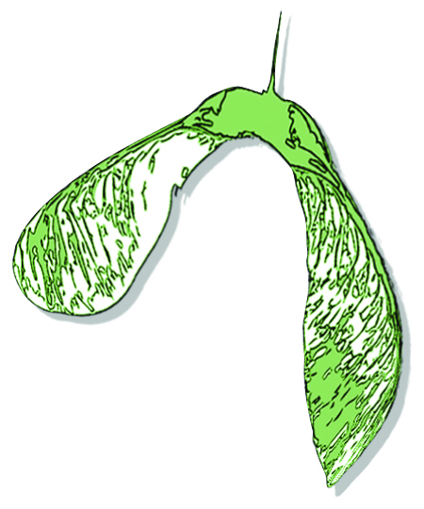
Initial Benefit-Risk Assessment of Activities in Nature-based Early Childhood Education

This benefit-risk assessment focuses on the specific activities that occur in a space. This tool should be used in tandem with a site assessment which identifies potential hazards in a space—no matter the activity occurring there. Once you’ve completed this initial benefit-risk assessment it’s recommended to generate detailed protocols for medium- and high-risk activities.

Location/Organization: |  | Date:
Assessor(s): |  | Scheduled review date:

The three questions driving this assessment: 1) What are the benefits of doing this activity? 2) How might we (or nature) get hurt doing this activity? 3) How can we keep ourselves, each other, and nature safe doing this activity?

Activity | How will young children benefit from this activity? | What are the possible risks of this activity? | Who is at risk? | What actions will be put in place to reduce the risk of injury? | Overall risk rating*: L/M/H
* Low, medium or high is a judgement of the relation of Risks to Benefits in the activity; Activities with a high or medium rating should have a detailed protocol written to reduce risk.
Modified by Samara Early Learning based on template created by Tim Gill at http://www.learningaway.org.uk

Activity | How will young children benefit from this activity? | What are the possible hazards of this activity? | Who is at risk? | What actions will be put in place to reduce the risk of injury? | Overall risk rating*: L/M/H
* Low, medium or high is a judgement of the relation of Risks to Benefits in the activity; Activities with a high or medium rating should have a detailed protocol written to reduce risk.
Modified by Samara Early Learning based on template created by Tim Gill at http://www.learningaway.org.uk

